WESTERN PACIFIC UNIVERSITY
CMN224 / CMP224 Software Engineering — Week 5
Lab 4: Architecture & UML for Your Client
Formative (ungraded) · Moodle-enabled ·

Part A — Answer the six design questions (25 min)
Answer for YOUR client (Kina Ridge Primary School or Waghi Valley Produce Cooperative). One or two sentences each — but each answer must be a decision, not a description.

No. | Question | Your decision, and the requirement that forced it
1 | What are the major parts of the  system? | Decision: Local database is the major part of Waghi Valley Produce Cooperative  Requirement: To track produce, farmer and producers information, and sales management
2 | How do the parts communicate? | Decision: Communicate through local Wifi services  Requirement: Since internet is not stable, or unreliable, local wifi service is first needed
3 | Where does the data live? | Decision: Data live n the cooperative local server  Requirement: Waghi valley has poor connectivity to internet
4 | Where does each part physically run? | Decision: For farmers it runs on smart phone, for staff a PC, and local database  Requirement: Uses existing devices already available
5 | How is access controlled, and where is  that enforced? | Decision: Access control through role based login. For example: Managers will be given preference (data insert, delete, update) over farmers and buyers.  Requirement: Farmers have access to their own records. Whereas staff or managers may manage data securely.
6 | What happens when it fails — power  loss, no signal, duplicate sync? | Decision: Uses it offline first, local cache or delayed sync  Requirement: Because it must work during power outage to avoid data loss.

Part B — Choose an architectural pattern (10 min)
Pattern chosen (or blend): Layered Architectural Pattern

In 100–150 words: why this pattern for THIS client? Name one pattern you rejected and the specific
requirement that ruled it out.
For Waghi Valley Produce Cooperative, Layered architecture is most suitable. Because farmers uses smart phone with local caching, while rely on PC connected to local database server. This practice may ensure that data entry and retrieval continue even power outage. Layered architecture seperates responsibilities. For example: farmers uses their smartphone, the staff uses PC connected to local database server. Layered approach also provides role bases access control at the local database that protects sensitive record, while allow farmers to manage their own data entries.

A Clien server was rejected because it relies on continuous connectivity. Given Waghi valley internet is unreliable and frequent outage, this will fail immediately, violating the requirement that system must continue function offline and avoid data loss during downtime.

Warning: if you chose client–server with one central database, check it against your Part A
question 6 answer. At a site with no reliable connectivity that choice fails on day one.

Part C — Draw the package diagram (25 min)
Show your system as 3–5 logical packages with dependency arrows. Rules: arrows point downward only; every package has one clear responsibility; no package is called “Miscellaneous”.
If you are using PlantUML, start from this

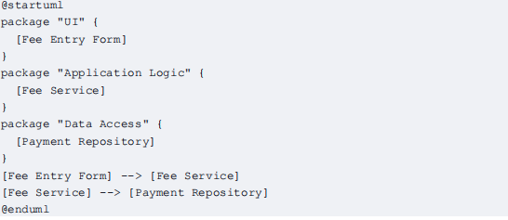
Save as week05/architecture-packages.puml (or .drawio from diagram.net).

@startuml
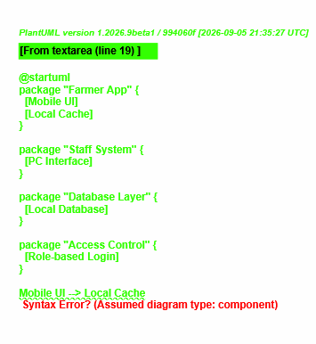
package "Farmer App" {
[Mobile UI]
[Local Cache]
}

package "Staff System" {
[PC Interface]
}

package "Database Layer" {
[Local Database]
}

package "Access Control" {
[Role-based Login]
}

Mobile UI --> Local Cache
PC Interface --> Local Database
Local Cache --> Local Database
Role-based Login --> Local Database
@enduml

* DIagram from PlantUML
Explaination
- Farmer App: smart phone and local cache for offline first data entry
- Staff: PC for cooperative staff
- Database Layer: Local Database
- Access Control: Role based login that enforces permission

Part D — Draw the deployment diagram (25 min)
Show every device your system runs on, what is installed on each, and the link between them. This is the diagram that exposes PNG delivery risk, so be honest about the network.

Must appear on your diagram

Every physical device (laptop,phone, office PC, printer)

What software component sits on each device

Where the data is stored on each device
The link between devices,labelled with how and how often it is available

A note on what still works while that link is DOWN

PlantUML deployment starter
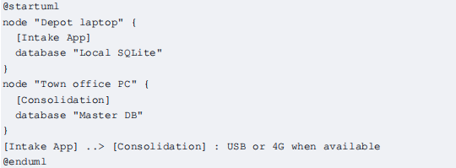

@startuml
node "Farmer Smartphone" {
artifact "Mobile App"
artifact "Local Cache"
}

node "Staff PC" {
artifact "PC Interface"
}

node "Local Server" {
artifact "Database"
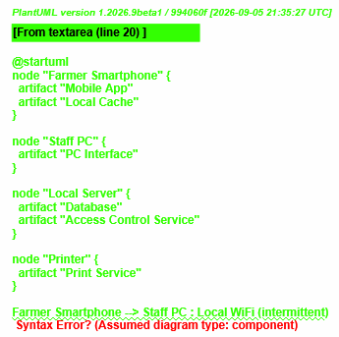
artifact "Access Control Service"
}

node "Printer" {
artifact "Print Service"
}

Farmer Smartphone --> Staff PC : Local WiFi (intermittent)
Staff PC --> Local Server : Local WiFi (continuous)
Local Server --> Printer : Local Network
@enduml

* Diagram from PlantUML

Part E — Commit (5 min)
1. Put both diagram files and this worksheet into week05/ in your portfolio.
2. Commit with a message that says what you decided, not just what you added:
git add week05/
git commit -m "Add offline-first architecture: package and deployment diagrams"

